Scentwork UK – Level 1 Beginners course.

Pennington – 25th January 2022 10.45am – 11.45am
Beginners Nose work training for dogs.
Scent work is when a dog uses its sense of smell to identify and locate a scent which it has been trained to detect.
Dogs have a highly sensitive nose, vastly superior to our own. Scentwork is a natural behaviour for a dog and essential in hunting and finding prey. As man’s best friend, this behaviour has been put to many uses – for example in police work, search and rescue, and hunting. As a dog sport, Scentwork has emerged from detection style nosework as practiced by customs and excise, explosives detection, search and rescue and medical detection dogs.
Scentwork UK has been set up to promote and develop scent work as a dog sport and training activity throughout the country.
- It is suitable for all breeds and ages, puppies and dogs with injuries or disabilities – scentwork is a non-injurious sport and every dogs and owner is welcome to enrol.
As a training activity, scentwork is fun, very rewarding and at the same time mentally tiring for your dog. It will improve the relationship between you and your dog and is a great confidence builder especially for the shy dog. You can participate whether it is just for fun or go on and enter trials and gain qualifications.
Scentwork UK is an organisation that provides scentwork trials and qualifications. Dogs are tested against a consistent national standard and can progress from beginners to advance by passing the individual levels at a Scentwork UK trial. Progression through the trials helps participants to focus on their training and to achieve small steps with modern reward-based training methods.

What will me and my dog learn on the five-week course.
- An introduction into “Scentwork UK”
- A simple “box” search- How to begin “finds”
- A mini “blind search to include some boxes and luggage against the clock!
- How to begin a vehicle search (Weather dependent!)
- Beginning a simple chair and table search.
- Beginning room search
- Searching for a level 1 odour and how to understand your dog’s body language
- How to teach dogs to indicate when on an odour
- Weekly homework
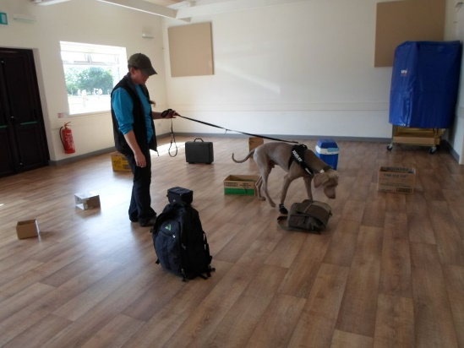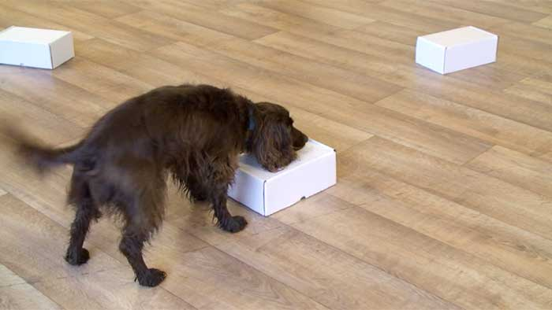
The course is held at
St Marks Community Hall
Ramley Road
Pennington
Lymington
SO41 8GQ – This venue is down a small road (there is sign at the end of the road- which might not be visible in the dark) The entrance is opposite North Street- A carpark is in front of the venue.
The class begins at 10.45am and finishes at 11.45am
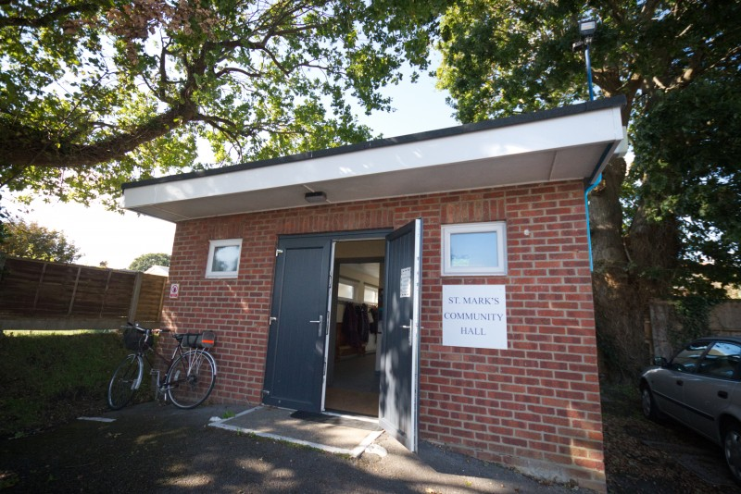

Course Dates
Sunday 23rd January
Sunday 30th January
Sunday 6th February
NO TRAINING ON SUNDAY 13th FEBRUARY
Sunday 20th February
Sunday 27th February

I am very much looking forward to meeting you and helping you develop a lifelong bond through kind, positive and effective training methods.
Michelle

You can follow our training on Facebook.

Scentwork UK - Training Course

BOOKING FORM –
Please complete the booking form and return to Michelle Richmond – 2, Island View, Manchester Road, Sway, Lymington. Hampshire, SO41 6AS or via return email. I would like to book for the Scentwork Course at Pennington – SUNDAY’s

Your Name:

Address: Contact Number:

Email address:

Would you like to attend with other members of the family? (maximum of one additional person/Child)

Dog’s Name: Breed:

Date of birth:
Diet feed/ any allergies relating to treats that may be used in training sessions:

The cost of the training course for one dog is £100.00

Payment is required before the course commences and guarantees your dog’s place.

Direct bank transfer can be made via the following account: M L Richmond
Sort- 110501 Account - 00250826

Training Course

Terms and Conditions
New Forest Dog Training Academy- Terms and Conditions
​
Classes/1-2-1s:
​
All classes including rolling must be paid for in blocks of five via BACs or via cheques / cash.
​
In the event you are unable to attend classes you have paid and booked but before the classes have started, we require five working days for a refund to be delivered. This includes a £15 administration fee.
​
In the event you are unable to attend classes you have paid for and booked but they have already started, we do not offer a refund for this set of classes unless for specific extenuating circumstances, which are determined on a case by case basis. If a particular course / session is cancelled due to unforeseen then another date/ session will be provided.

You must not knowingly book an aggressive or highly reactive dog into one of our classes or 1-2-1s without informing us first. In the event it is discovered your dog is aggressive or highly reactive in the class setting, you may be asked to leave and not be offered a refund.
If unsure of your dog’s level of aggression or reactivity, we will offer an evaluation at one of our outdoor venues to determine suitability for classes. In the event your dog is uncomfortable or reactive within the class environment, we will offer an alternative solution such as 121 sessions in order for you and your dog to meet your goals and needs.
​
All dogs must be kept under control at all times. When dogs are not being worked, they must either be in a crate or on leash near their handler. Dogs are not allowed off leash unless specifically instructed by the instructor.
​
All dog poo must be picked up by the dog’s respective owner at all the venues.
​
When attending classes, students must bring their own dog food and poo bags. New Forest Dog Training Academy has no responsibility for any allergens or allergic reactions your dog has while at New Forest Dog Training Academy’s, 1-2-1s, workshops and seminars.
​
New Forest Dog Training Academy will endeavour to run training classes in a professional, organised and safe manner for all involved. New Forest Dog Training Academy is fully insured with public liability insurance suitable for running dog training classes, 1-2-1s, seminars and workshops. Participation in New Forest Dog Training Academy’s various classes, 1-2-1s, seminars and workshops is entirely at risk of the participant and their dog.

New Forest Dog Training Academy, it’s staff, volunteers and owners of our training venues take no responsibility for injuries or losses sustained that are not covered by New Forest Dog Training Academy’s Insurance.
Handlers remain responsible for their own dogs at all times and are advised to have pet insurance covering their animal in the highly unlikely event of injury or an accident to occur to a third party.

1-2-1 Training sessions will require payment either by BACs five days prior to New Forest Dog Training Academy attending your home. Cancellations made later than five days prior to New Forest Dog Training Academy attending will not be refunded unless specific extenuating circumstances.

New Forest Dog Training Academy advises that for 1-2-1 training sessions carried out in public advised that your dog has a suitable insurance policy covering public liability in the highly unlikely event of injury or an accident. The owner is responsible for their dog at all times

Other:
​
New Forest Dog Training Academy follows the IMDT Code of Ethics, which prohibits the use of choke chains, prong collars and shock collars in any of our classes or 1-2-1s.
​
New Forest Dog Training Academy reserves the right to take photographic, video and audio content of all New Forest Dog Training related activities including classes, 1-2-1s, seminars and workshops. By agreeing to the terms and conditions you agree that both yourself and your dog are able to be used for marketing purposes on New Forest Dog Training website and social media accounts.

