Kennel Club - Puppy Foundation Training Course- Pennington - THURSDAY 11th November
Dear very proud puppy parent.
Thank you for your interest in the puppy foundation course. A recognised Kennel Club scheme designed to provide a fun, professional and kind training course for puppies from the age of 9 weeks and up to 5 months
The puppy course runs for a period of 5 weeks on Wednesday at St Marks Community Hall-Ramley Road, Pennington, Hampshire, SO41 8GQ
The class begins at 7pm and finishes at 7.45pm
The attention span of puppies is short, and the forty-five minute session provide the ideal length of time for your puppy to concentration and keep inquisitive minds active!
Puppies are continually assessed on a weekly basis and at the end of the course successful puppies receive the KC Puppy Foundation Certificate and rosette.
The classes are purposely small with a maximum of five puppies all a compatible age and size (if possible)
The course dates are as follows –
Thursday 11th November
Thursday 18th November
Thursday 25th November
Thursday 2nd December
Thursday 9th December

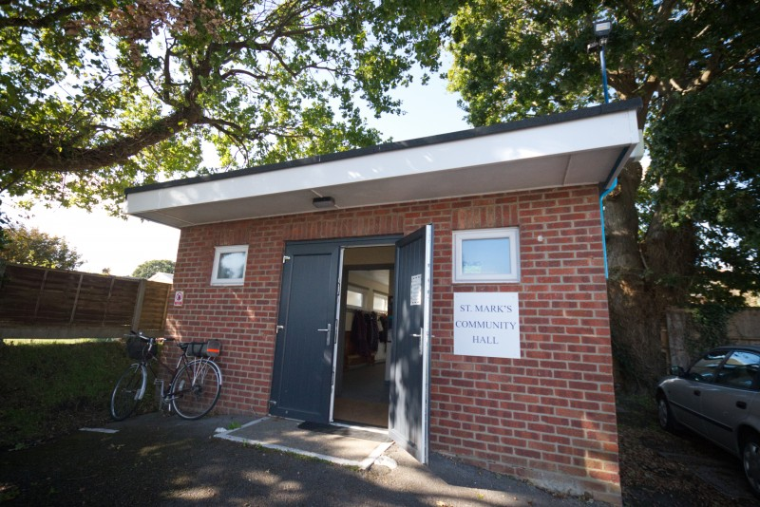
St Marks Community Hall
Ramley Road
Pennington
Lymington
SO41 8GQ – This venue is down a small road (there is sign at the end of the road- which might not be visible in the dark) The entrance is opposite North Street- A carpark is in front of the venue.
Course options
The course requires puppies to attend the five and payment is required at the time of booking.
1) KC Puppy Foundation classes ONLY = £100.00
2) KC Puppy Foundation classes PLUS the complete Puppy Training Academy Course
(Over fifty puppy videos and additional training guides) = £130.00 (70% discount!)
Puppy training – what will I need to bring along?
- Favourite toy.
- Puppies should wear a flat collar or a harness.
- Clip on lead- no extending leads.
- Treats! (Considered high value for your puppy such as cheese, ham, chopped cocktail sausages, chicken) Please make sure the treats are cut into small pieces.
- A treat bag, ideally one that can be clipped onto your clothing.
- A clicker (this is optional)
- A puppy long line/ training line .
- Small blanket.
- Poop bags.
- Vaccination card (Only for the first lesson).
- Lots of questions and an abundance of enthusiasm!
I am very much looking forward to meeting your new puppy and helping you develop a lifelong bond through kind, positive and effective training methods.
Michelle

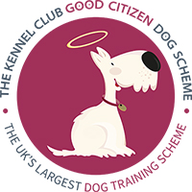

You can follow our training on Facebook.

www.newforestdogtrainingacademy.com
The Kennel Club Good Citizen Dog Scheme
www.thekennelclub.org.uk
The Kennel Club Good Citizen Dog Scheme is the largest dog training programme in the UK. Now a well-established dog training programme that has been in operation since 1992. The Scheme is open to all dogs, young or old, pedigree or Crossbreed, whether Kennel Club registered or not.
﻿It provides a quality standard of training for dogs and owners, and incorporates many domestic obedience exercises, with over 481,000 certificates of achievement having being awarded to owners and their dogs who have successfully passed the scheme's tests. There are currently around 1,800 dog training clubs and other organisations around the country actively administering the scheme.﻿

Kennel Club - Puppy Foundation Training Course BOOKING FORM – PENNINGTON
Please complete the booking form and return to Michelle Richmond – 2, Island View, Manchester Road, Sway, Lymington. Hampshire, SO41 6AS or via return email. I would like to book for the training session starting Thursday 11th November
I have read and understood the terms and conditions and details relating to Covid

Your Name:

Address: Contact Number:

Email address:
Please be aware that ONLY one member of the family can attend the training classes due to the current restrictions.

Puppy’s Name: Breed:

Date of birth:
Diet feed/ any allergies relating to treats that may be used in training sessions:

The cost of the training course for one puppy is £100.00 without the Puppy Academy Online Course or £130.00 including the Puppy Academy Online Course.
Payment is required before the course commences and guarantees your puppy’s place.
Direct bank transfer can be made via the following account: M L Richmond
Sort- 110501 Account - 00250826
I have read the terms and conditions below.

Kennel Club – Puppy Foundation Training Course

Terms and Conditions
New Forest Dog Training Academy- Terms and Conditions
​
Classes/1-2-1s:

COVID CONSIDERATIONS – If you or a member of your house has been told to self-isolate, please do remain at home – An alternative session will be provided via a 30 minute Zoom 1-2-1 session. If the instructors has been advised to self-isolate, all training will continue online.
​
All classes including rolling must be paid for in blocks of five via BACs or via cheques / cash.
​
In the event you are unable to attend classes you have paid and booked but before the classes have started, we require five working days for a refund to be delivered. This includes a £15 administration fee.
​
In the event you are unable to attend classes you have paid for and booked but they have already started, we do not offer a refund for this set of classes unless for specific extenuating circumstances, which are determined on a case by case basis. If a particular course / session is cancelled due to unforeseen then another date/ session will be provided.

You must not knowingly book an aggressive or highly reactive dog into one of our classes or 1-2-1s without informing us first. In the event it is discovered your dog is aggressive or highly reactive in the class setting, you may be asked to leave and not be offered a refund.
If unsure of your dog’s level of aggression or reactivity, we will offer an evaluation at one of our outdoor venues to determine suitability for classes. In the event your dog is uncomfortable or reactive within the class environment, we will offer an alternative solution such as 121 sessions in order for you and your dog to meet your goals and needs.
​
All dogs must be kept under control at all times. When dogs are not being worked, they must either be in a crate or on leash near their handler. Dogs are not allowed off leash unless specifically instructed by the instructor.
​
All dog poo must be picked up by the dog’s respective owner at all the venues.
​
When attending classes, students must bring their own dog food and poo bags. New Forest Dog Training Academy has no responsibility for any allergens or allergic reactions your dog has while at New Forest Dog Training Academy’s, 1-2-1s, workshops and seminars.
​
New Forest Dog Training Academy will endeavour to run training classes in a professional, organised and safe manner for all involved. New Forest Dog Training Academy is fully insured with public liability insurance suitable for running dog training classes, 1-2-1s, seminars and workshops. Participation in New Forest Dog Training Academy’s various classes, 1-2-1s, seminars and workshops is entirely at risk of the participant and their dog.

New Forest Dog Training Academy, it’s staff, volunteers and owners of our training venues take no responsibility for injuries or losses sustained that are not covered by New Forest Dog Training Academy’s Insurance.
Handlers remain responsible for their own dogs at all times and are advised to have pet insurance covering their animal in the highly unlikely event of injury or an accident to occur to a third party.

1-2-1 Training sessions will require payment either by BACs five days prior to New Forest Dog Training Academy attending your home. Cancellations made later than five days prior to New Forest Dog Training Academy attending will not be refunded unless specific extenuating circumstances.

New Forest Dog Training Acemey For 1-2-1 training sessions carried out in public advised that your dog has a suitable insurance policy covering public liability in the highly unlikely event of injury or an accident. The owner is responsible for their dog at all times

Other:
​
New Forest Dog Training Academy follows the IMDT Code of Ethics, which prohibits the use of choke chains, prong collars and shock collars in any of our classes or 1-2-1s.
​
New Forest Dog Training Academy reserves the right to take photographic, video and audio content of all New Forest Dog Training related activities including classes, 1-2-1s, seminars and workshops. By agreeing to the terms and conditions you agree that both yourself and your dog are able to be used for marketing purposes on New Forest Dog Training website and social media accounts.

